Crop Irrigation – Best Practices

Criteria for Effective Plot Irrigation

Functional Criteria – System should enable complete and adjustable coverage. Depending on how you plant, you may need to irrigate your whole plot or just parts of it during different times of the year. To achieve this, you will need a system that is highly adjustable and that doesn’t overspray the aisles or unplanted areas.

Practical Criteria – System should be efficient, reliable, and affordable. The farm’s well is limited so we need to use water wisely. The system should not require a lot of maintenance to keep working so that it will irrigate reliably when we’re away. Price may also be a consideration if numerous irrigation components are needed.

Pros and Cons of Various Irrigation Methods

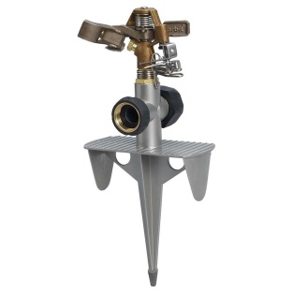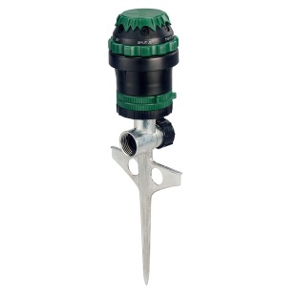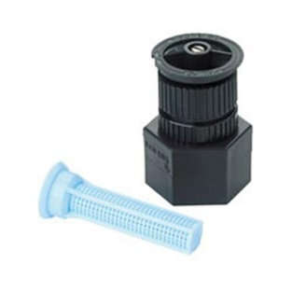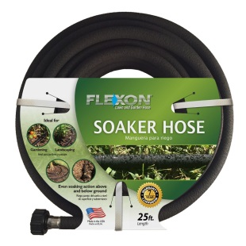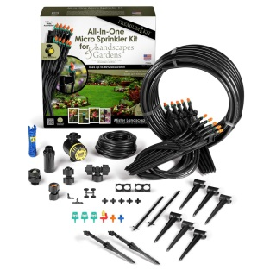
Impulse Sprinkler Rotors Spray Heads Soaker Hose Microsprayer

Impulse Sprinklers – Pros: easy, cheap ($10-20/plot) and reliable. Good for open plots. Cons: very wasteful, hard to precisely control coverage, very pressure dependent, wets foliage, applies in radius pattern only.
Rotors – Pros: more efficient and controllable than impulse sprinklers. Good for open plots. Cons: slightly more expensive ($20-30/plot), somewhat pressure dependent, wets foliage, applies radius pattern only.
Spray Heads – Pros: more efficient and versatile than rotors at about the same cost. Various patterns are available so OK for open plots. Cons: slightly pressure sensitive, wets foliage, must clean filters regularly.
Soaker Hoses – Pros: Very efficient, extremely versatile and adjustable, not pressure sensitive, doesn’t wet foliage. Good for open plots or raised beds. Cons: More expensive ($40-60/plot), limited lifetime (1-2 years) due to hard water clogging and UV degradation. Must be taken up and reset during tilling and planting.
Drip Lines/Micro Sprayers – Pros: Very efficient, extremely versatile and adjustable, not pressure sensitive, micro sprayers may wet foliage but drip lines don’t. Not recommended for open plots but best option for raised beds. Cons: More expensive ($40-60/plot), must reinstall when replanting, lifetime unknown.

How to Operate your Irrigation System

How much to water: The Clemson Agricultural Extension Service recommends applying between one-half and one inch of water at a time. Our sandy soil does not retain water well so additional irrigation is wasted.
In addition, too much water will flush the nutrients out of your soil. To measure how much water you are applying collect your irrigation in a container or buy a moisture meter from Lowes.
How often to water: Crops should be watered no more frequently than every other day although seeds and newly planted crops will probably have to be watered more often. Daily watering promotes a weak, shallow root system in your plants. Mature crops that require daily watering indicate poor soil quality. Add compost!
When to water: The best time to water is in the morning after 5AM but before it gets too hot. Water applied in the heat of the day evaporates too quickly to be absorbed into the soil and watering at night can leave your soil and plants wet for too long thus exposing them to fungus and disease.

